**Day 4**

Github:https://github.com/Senthamil2003/DailyPracticePresidioIntern/tree/master/Day4(Object%20oriented%20in%20C%23)

**1.Doctor Management**

**1.1Adding Doctors in Array**

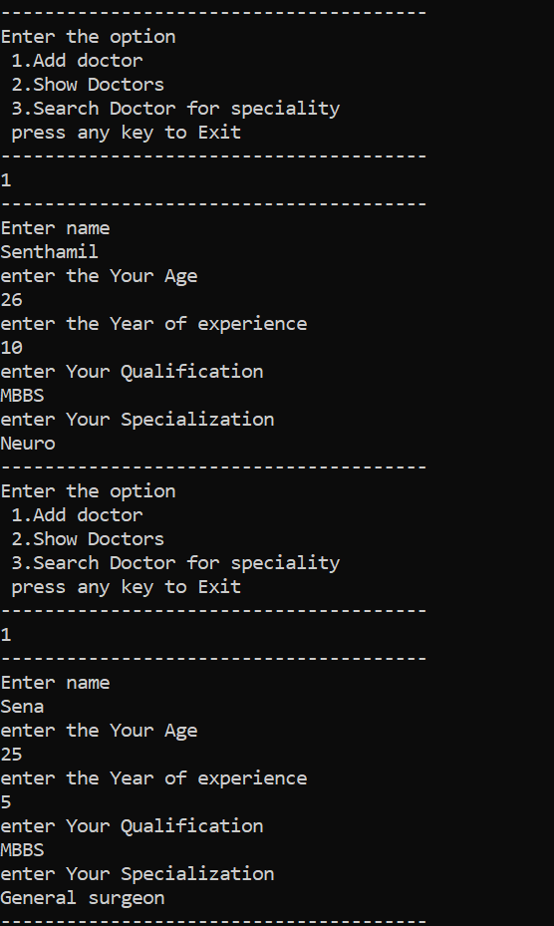

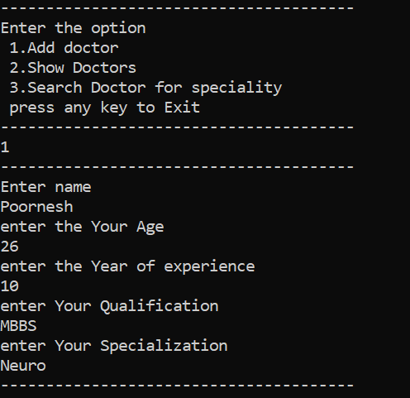

**1.2 Display Doctors**

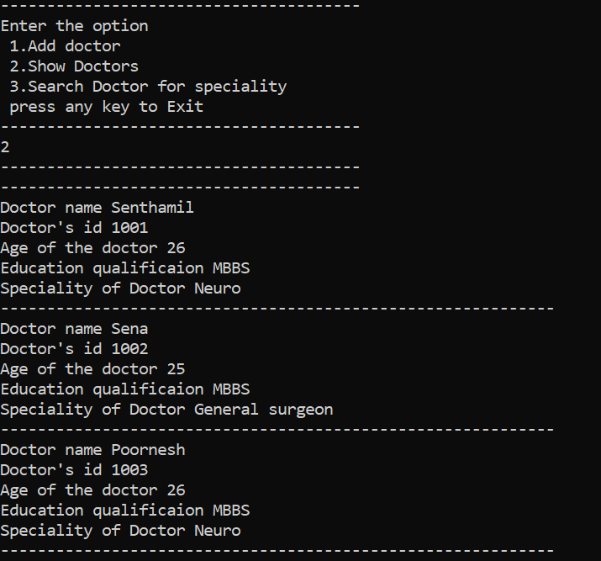

**1.3 Search for specialization**

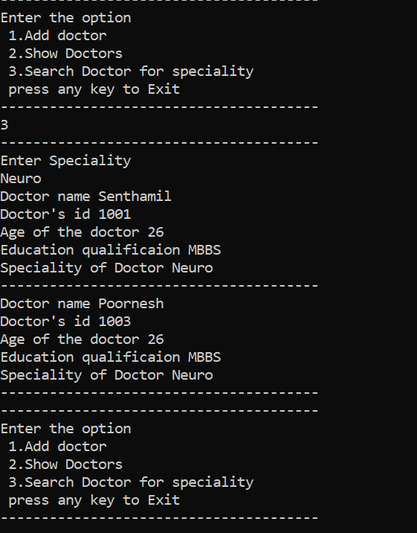

**2.Credit Card Validator**

